VPC TASK 2

1. Create one VPC, with 1 one public subnet and 1 private subnet.

Created 1 vpc I virgina region   
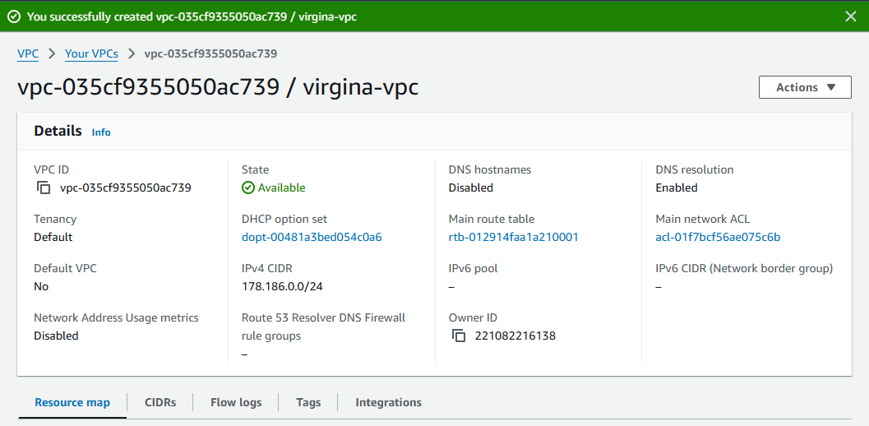

I have created 2subnets with name as public-subnetV1, private-subnetV1   
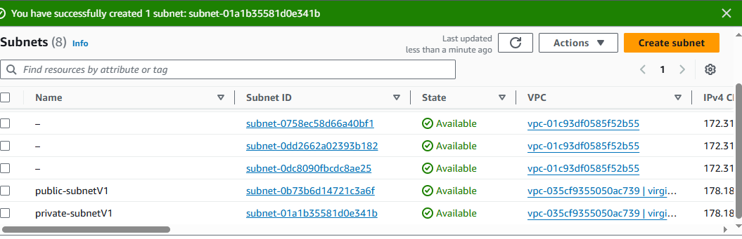

Given internet access to the public subnet  
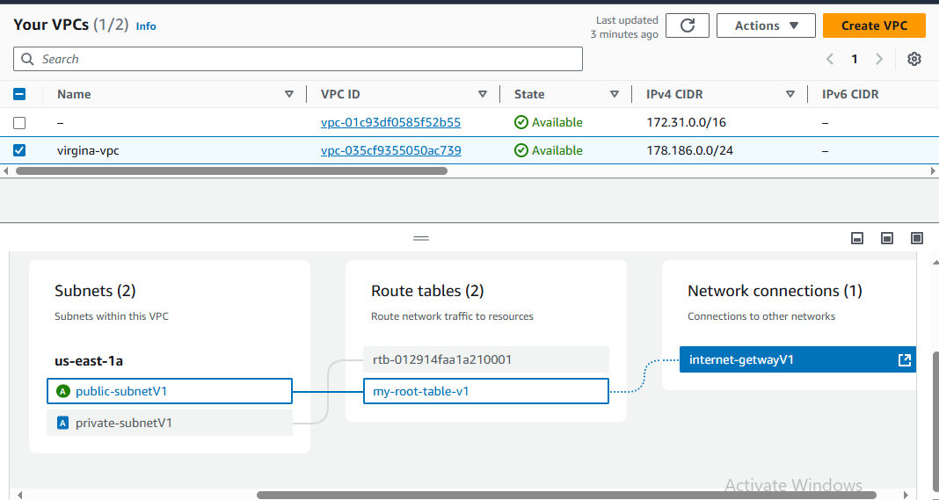

2) Enable VPC peering for cross region.  
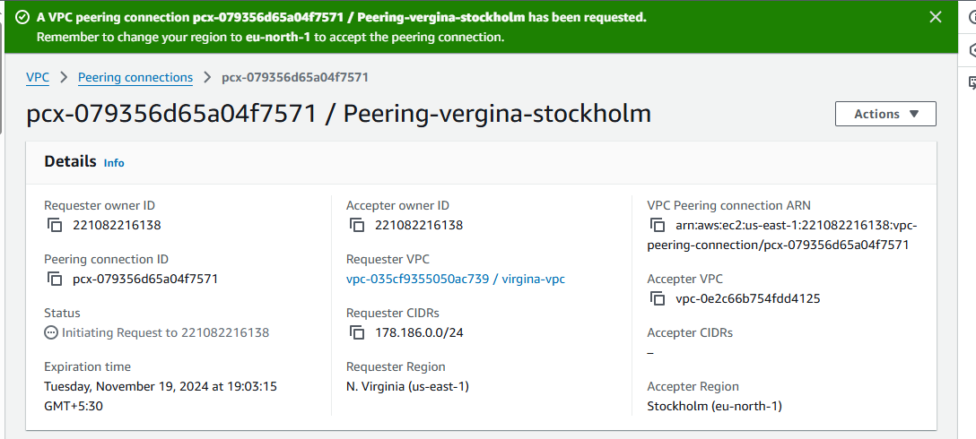

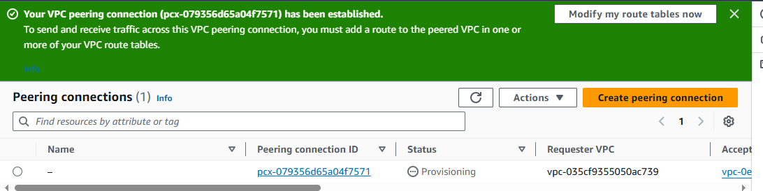

3) Enable VPC peering for cross account. (You can collaborate with your friend and do this task).

4) Setup VPC Transist gateway.   
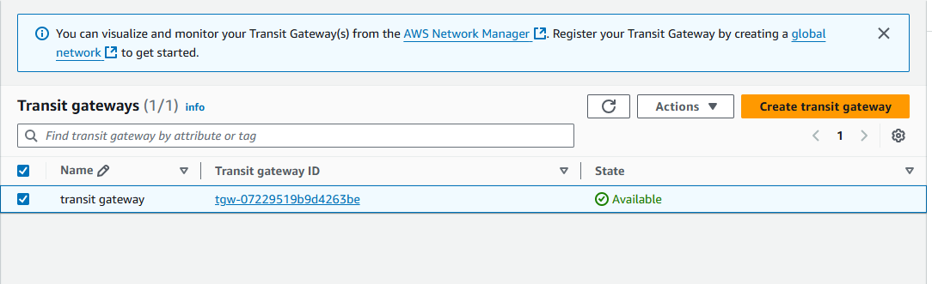

5) Setup VPC End Point.  
